Technology Stack Migration

🌟 Definition
# Source: AI Source: Provided by: [Data Path: Persons Table -> ID Column: 1, Name_En Column: Motasem Essam] -> From: [ChatGPT] on [6/7/2026]
Technology Stack Migration is the process of moving an application from one set of technologies (programming languages, frameworks, databases, servers, and tools) to another technology stack.
Unlike Framework Migration, which changes only the framework, Technology Stack Migration may change multiple layers of the application.

🎯 Purpose
# Source: AI Source: Provided by: [Data Path: Persons Table -> ID Column: 1, Name_En Column: Motasem Essam] -> From: [ChatGPT] on [6/7/2026]
Technology stack migration is performed to:
- Modernize legacy systems
- Improve performance
- Improve scalability
- Reduce maintenance costs
- Improve developer productivity
- Support cloud-native development
- Improve security

🧠 Simple Definition
# Source: AI Source: Provided by: [Data Path: Persons Table -> ID Column: 1, Name_En Column: Motasem Essam] -> From: [ChatGPT] on [6/7/2026]
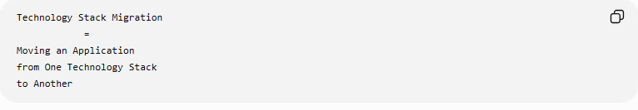
Technology Stack Migration
=
Moving an Application
from One Technology Stack
to Another

📚 What is a Technology Stack?
# Source: AI Source: Provided by: [Data Path: Persons Table -> ID Column: 1, Name_En Column: Motasem Essam] -> From: [ChatGPT] on [6/7/2026]
A technology stack is the collection of technologies used to build and run an application.
Typical stack components:
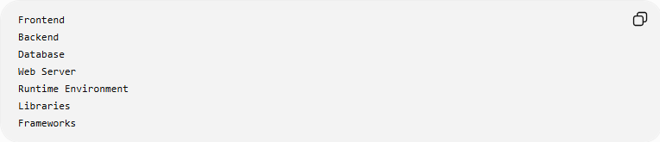
Frontend
Backend
Database
Web Server
Runtime Environment
Libraries
Frameworks

🏗️ Example Technology Stack
# Source: AI Source: Provided by: [Data Path: Persons Table -> ID Column: 1, Name_En Column: Motasem Essam] -> From: [ChatGPT] on [6/7/2026]
Old Stack
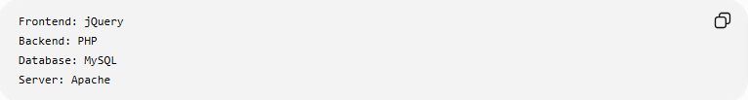
Frontend: jQuery
Backend: PHP
Database: MySQL
Server: Apache

New Stack
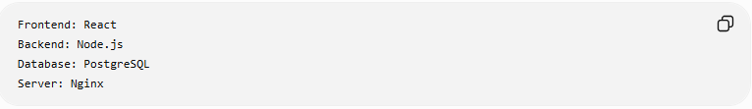
Frontend: React
Backend: Node.js
Database: PostgreSQL
Server: Nginx

🔍 Common Technology Stack Migrations

1️⃣ PHP Stack → Node.js Stack
# Source: AI Source: Provided by: [Data Path: Persons Table -> ID Column: 1, Name_En Column: Motasem Essam] -> From: [ChatGPT] on [6/7/2026]
Before
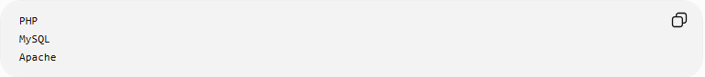
PHP
MySQL
Apache

After
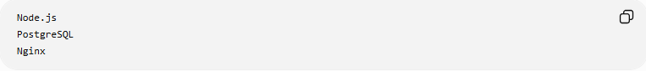
Node.js
PostgreSQL
Nginx

Benefits:
Better Scalability
Modern Ecosystem

2️⃣ LAMP → MERN
# Source: AI Source: Provided by: [Data Path: Persons Table -> ID Column: 1, Name_En Column: Motasem Essam] -> From: [ChatGPT] on [6/7/2026]
Before (LAMP)
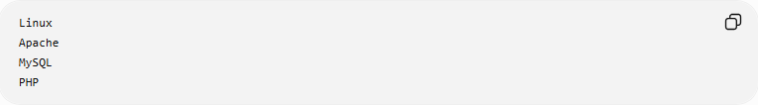
Linux
Apache
MySQL
PHP

After (MERN)
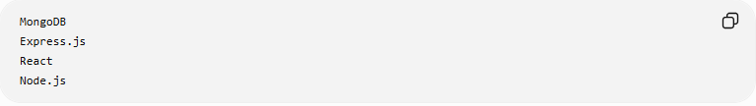
MongoDB
Express.js
React
Node.js

Benefits:
Full JavaScript Stack
Modern Frontend

3️⃣ Java EE → Spring Boot
# Source: AI Source: Provided by: [Data Path: Persons Table -> ID Column: 1, Name_En Column: Motasem Essam] -> From: [ChatGPT] on [6/7/2026]
Before
Java EE

After
Spring Boot

Benefits:
Microservices
Cloud Readiness

4️⃣ Monolithic Stack → Cloud-Native Stack
# Source: AI Source: Provided by: [Data Path: Persons Table -> ID Column: 1, Name_En Column: Motasem Essam] -> From: [ChatGPT] on [6/7/2026]
Before
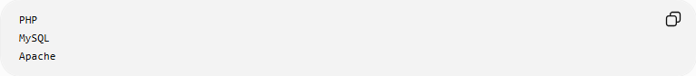
PHP
MySQL
Apache

After
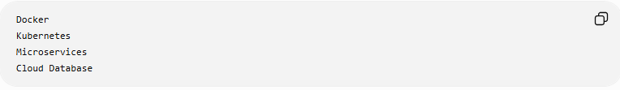
Docker
Kubernetes
Microservices
Cloud Database

Benefits:
Scalability
Automation

🛠️ Real-World Example
# Source: AI Source: Provided by: [Data Path: Persons Table -> ID Column: 1, Name_En Column: Motasem Essam] -> From: [ChatGPT] on [6/7/2026]
Old Application
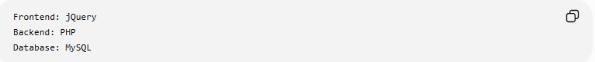
Frontend: jQuery
Backend: PHP
Database: MySQL
Problems:
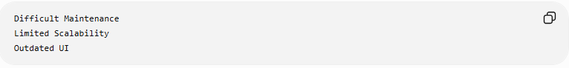
Difficult Maintenance
Limited Scalability
Outdated UI

Migration
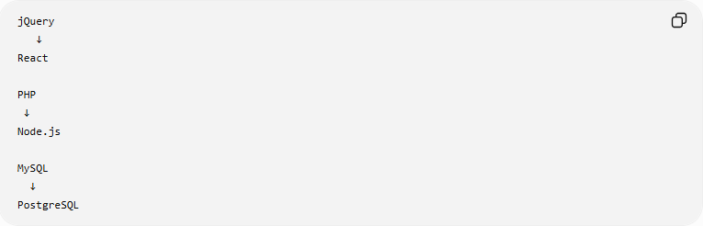
jQuery
↓
React

PHP
↓
Node.js

MySQL
↓
PostgreSQL

New Application
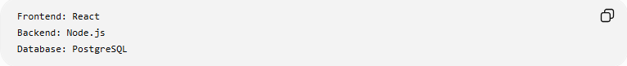
Frontend: React
Backend: Node.js
Database: PostgreSQL
Benefits:
Better Performance
Modern Architecture

🔄 Technology Stack Migration Lifecycle
# Source: AI Source: Provided by: [Data Path: Persons Table -> ID Column: 1, Name_En Column: Motasem Essam] -> From: [ChatGPT] on [6/7/2026]
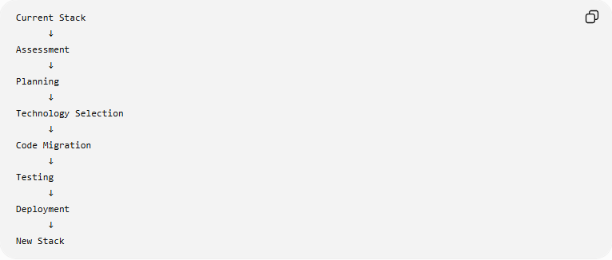
Current Stack
↓
Assessment
↓
Planning
↓
Technology Selection
↓
Code Migration
↓
Testing
↓
Deployment
↓
New Stack

📦 Components That May Change
# Source: AI Source: Provided by: [Data Path: Persons Table -> ID Column: 1, Name_En Column: Motasem Essam] -> From: [ChatGPT] on [6/7/2026]
Frontend Technology
Before
jQuery
AngularJS

After
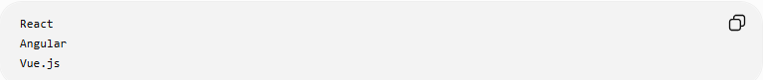
React
Angular
Vue.js

Backend Technology
Before
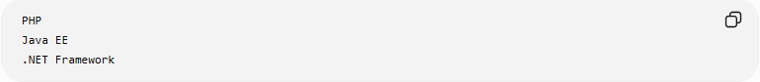
PHP
Java EE
.NET Framework

After
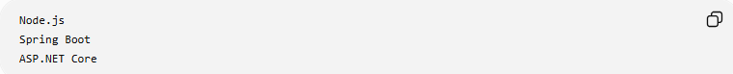
Node.js
Spring Boot
ASP.NET Core

Database
Before
MySQL

After
PostgreSQL
MongoDB

Server Infrastructure
Before
Apache

After
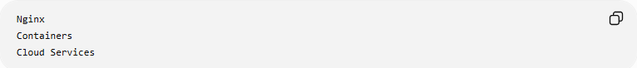
Nginx
Containers
Cloud Services

🌍 Popular Technology Stacks
# Source: AI Source: Provided by: [Data Path: Persons Table -> ID Column: 1, Name_En Column: Motasem Essam] -> From: [ChatGPT] on [6/7/2026]
LAMP Stack
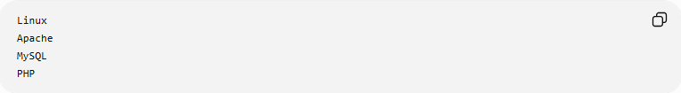
Linux
Apache
MySQL
PHP

MEAN Stack
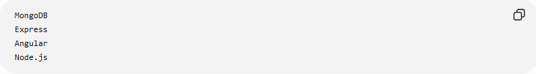
MongoDB
Express
Angular
Node.js

MERN Stack
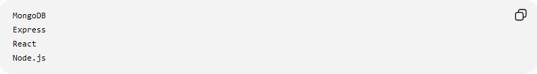
MongoDB
Express
React
Node.js

JAMstack
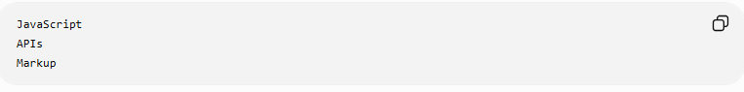
JavaScript
APIs
Markup

.NET Stack
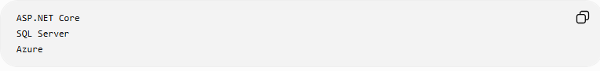
ASP.NET Core
SQL Server
Azure

⚠️ Common Challenges
# Source: AI Source: Provided by: [Data Path: Persons Table -> ID Column: 1, Name_En Column: Motasem Essam] -> From: [ChatGPT] on [6/7/2026]
Large Code Rewrite
Many technologies may change simultaneously.

Learning Curve
Developers must learn:
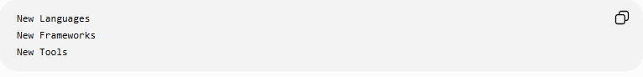
New Languages
New Frameworks
New Tools

Data Migration
Database changes may require:
Schema Conversion
Data Conversion

Integration Issues
External systems may need updates.

Project Cost
Technology stack migrations are often expensive and time-consuming.

✅ Benefits
# Source: AI Source: Provided by: [Data Path: Persons Table -> ID Column: 1, Name_En Column: Motasem Essam] -> From: [ChatGPT] on [6/7/2026]
Modern Architecture
Cleaner Design
Better Maintainability

Better Performance
Faster Response Times

Scalability
Handle More Users

Improved Security
Modern technologies provide:
Security Updates
Built-In Protection

Easier Cloud Adoption
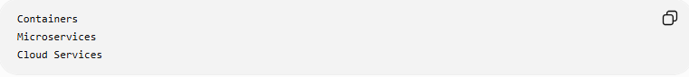
Containers
Microservices
Cloud Services

📊 Technology Stack Migration vs Framework Migration
# Source: AI Source: Provided by: [Data Path: Persons Table -> ID Column: 1, Name_En Column: Motasem Essam] -> From: [ChatGPT] on [6/7/2026]
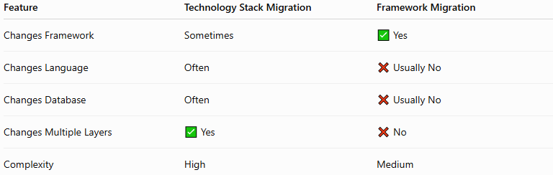
Feature | Technology Stack Migration | Framework Migration
Changes Framework | Sometimes | ✅ Yes
Changes Language | Often | ❌ Usually No
Changes Database | Often | ❌ Usually No
Changes Multiple Layers | ✅ Yes | ❌ No
Complexity | High | Medium

Framework Migration
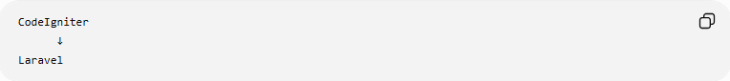
CodeIgniter
↓
Laravel
Only framework changes.

Technology Stack Migration
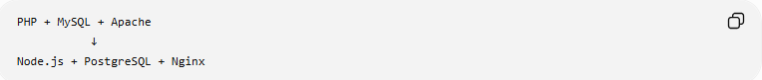
PHP + MySQL + Apache
↓
Node.js + PostgreSQL + Nginx
Multiple technologies change.

🛠️ Common Technologies Involved
# Source: AI Source: Provided by: [Data Path: Persons Table -> ID Column: 1, Name_En Column: Motasem Essam] -> From: [ChatGPT] on [6/7/2026]
Frontend
- React
- Angular
- Vue.js
Backend
- Node.js
- Spring Boot
- ASP.NET Core
Databases
- MySQL
- PostgreSQL
- MongoDB

🧠 Simple Analogy
# Source: AI Source: Provided by: [Data Path: Persons Table -> ID Column: 1, Name_En Column: Motasem Essam] -> From: [ChatGPT] on [6/7/2026]
Imagine rebuilding a restaurant.
Before
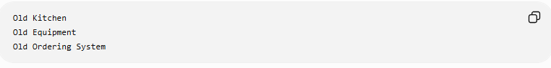
Old Kitchen
Old Equipment
Old Ordering System

Migration
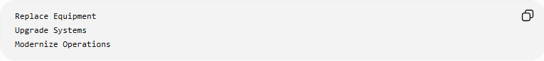
Replace Equipment
Upgrade Systems
Modernize Operations

After
Modern Restaurant
The restaurant serves the same customers, but almost everything behind the scenes has been upgraded.
Technology stack migration works the same way:
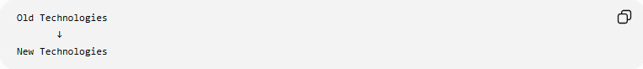
Old Technologies
↓
New Technologies
while keeping the application's business purpose intact.

🧭 Summary
# Source: AI Source: Provided by: [Data Path: Persons Table -> ID Column: 1, Name_En Column: Motasem Essam] -> From: [ChatGPT] on [6/7/2026]
Technology Stack Migration is a type of application migration that moves software from one collection of technologies to another. It can involve changing programming languages, frameworks, databases, servers, and infrastructure at the same time. Common examples include LAMP → MERN, PHP → Node.js, Java EE → Spring Boot, and legacy applications → cloud-native architectures. Its primary goal is to modernize applications, improve scalability, performance, maintainability, and prepare systems for future growth.

